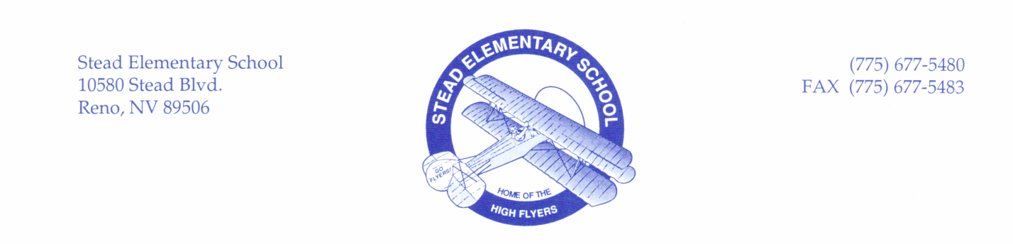

**Stead Elementary School Uniform Policy**

Stead Elementary believes that school uniforms fosters a safer and more orderly environment, one that supports a sense of belonging and instills high standards of academic performance. Please help the school to maintain an appropriate school climate by ensuring that your child is in uniform each day.

|  |
| --- |
| **Shirts/Blouses**   * With or without collars, long or short sleeved, with or without logo in solid colors of Black, Blue and Gray |
| **Sweaters/Sweatshirts/Pullover Hoodies**   * **SWEATSHIRTS:** without hoods, with or without school logo allowed in solid colors of Black, Blue and Gray * **PULLOVER HOODIES and ZIPPERED SWEATSHIRTS:** are considered outerwear and do not need to comply with uniform requirements, but must be worn over approved school uniform shirt |
| **Bottoms**   * **PANTS/SHORTS:** Khaki, Black, Blue and Gray pants allowed. Blue and Black jeans * **SWEATPANTS:** in solid colors of Black, Blue and Gray * **SKIRTS/SKORTS:** in solid colors of Khaki, Black, Blue and Gray (blue jean material allowed) * **JUMPERS/DRESSES:** in solid colors of Khaki, Black, Blue, Gray allowed. Blue jean material * **TIGHTS/LEGGINGS:** in solid color of Black, Blue and Gray |
| Uniforms must be worn each day unless picture day or designated spirit days during reading week. Students are not required to participate in spirit days and are not required to be in uniform on these days. |
| Information regarding Free/Spirit Days (exemption days) will be sent via ConnectEd messages and flyers through student backpacks. Students are not required to wear uniforms on these days. |
| Financial assistance: Contact the office for assistance. Most second-hand stores carry solid color tops and bottoms that fit the uniform requirements. |
| *All items of clothing must be in solid colors only with no pattern, no words, no brand logos. The school logo may only include the school name and/or school mascot. No other names or symbols related to school athletic teams, school clubs/activities/charitable organizations, or similar groups/organizations should be on the clothing. Colors and styles of outerwear, such as jackets and coats, are not required to meet the color/style specifications.  *This uniform policy is in addition to the WCSD standard dress code policy. |
| Progressive Discipline: if a student is not in uniform, they will be given borrowed clothes from the Clinic for the day. These must be washed and returned. If a student is repeatedly not in uniform after more than 3 warnings and clothing exchanges, the student will receive a minor office referral for each incident. |